BILKENT UNIVERSITY


MECHANICAL ENGINEERING DEPARTMENT

ME 232 –MECHANICS AND MATERIALS II
EXPERIMENT REPORT

Fracture Test
Ahmet Nuri Kirişci
22003024 Section-1
Group: Day 4 Group 1

Submitted: 21.05.2023

1. Calculations:

      - Derivation of the gross stress S_{g} expression:

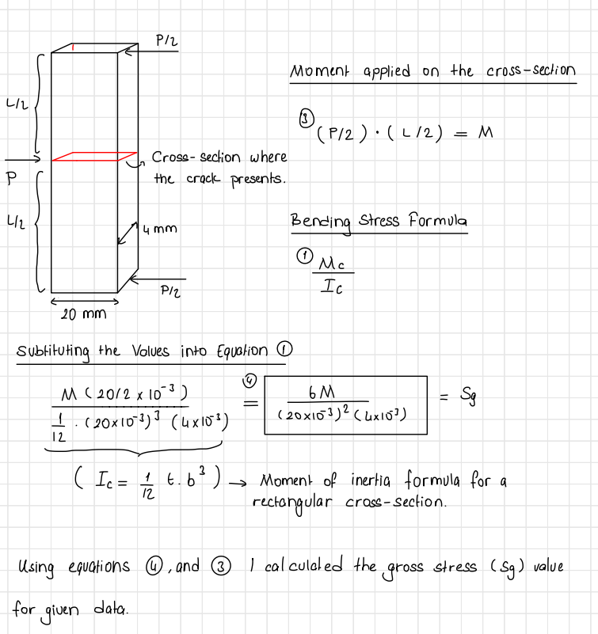

      - Expression for the fracture toughness K_{IC}:

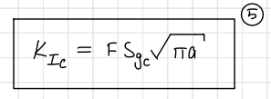

      - Fracture toughness K_{IC} for each specimen:
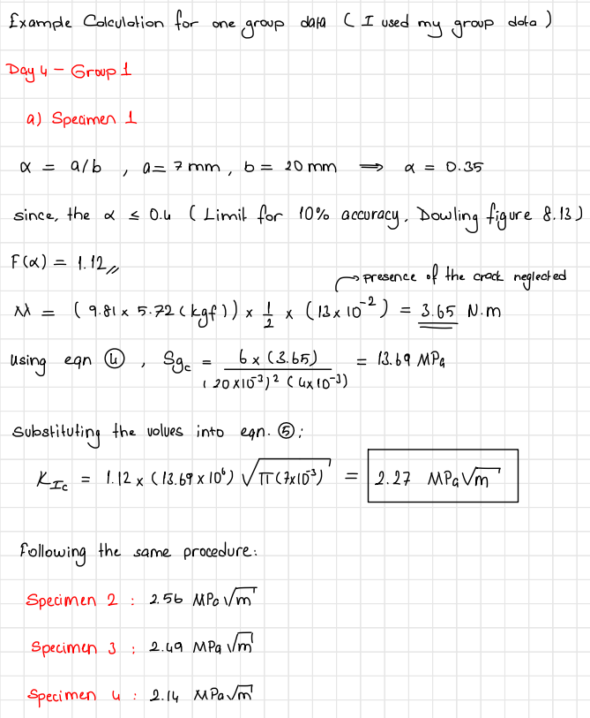

- Statistics

- Mean Values:
Specimen1 = 1.88
Specimen2 = 2.10
Specimen3 = 2.11
Specimen4 = 1.81

- Standard Deviation:
Specimen1 = 0.236
Specimen2 = 0.225
Specimen3 = 0.279
Specimen4 = 0.235

- First of all there is always an error due to the experimental setup which causes values to deviate. Besides that data is gathered by different experiment groups from different people which creates human error. However, on top of everything, each experiment group uses a different specimen since the specimens in the experiments are loaded until fracture. The differences between these specimens due to manufacturing, and imperfections within the material cause fracture toughness values to deviate, and scatter for the specimens with the same type. Differences between fracture toughness values for different types of specimens are reasonable since they have different lengths and crack sizes. Also, there is an error since the gross stress is calculated by omitting the presence of the crack and the form factor is taken as 1.12 since the 10% assumption holds.

- When the standard deviation values are considered for the specimens, it is observed that it changes in a range of 0.225-0.279, implying that the experimental procedure has give or take consistent in the measurements. When the mean values are compared for specific day-group data (Day4-Group1) calculated values deviate from the mean value in a similar fashion with such a range of 0.33-0.46 which again implies the consistency. When the calculated fracture toughness values are compared with tabulated polymeric material properties, calculated values turn out to be reasonable since for polymers fracture toughness values are in the order of 0.1 and 1.0

- The K_{IC} value is actually an intensity factor for the crack tip which is regarding the form factor, gross stress, and mode of force applied. Even though the K_{IC} values are tabulated for some materials, they can deviate for different scenarios since it is acquired from the experimental data under specific conditions as mentioned. So because of that K_{IC} is not expected to be exactly the same for different specimens.

- Polymeric materials can exhibit different kinds of fracture, since their ductility change. Brittle fracture is a type of fracture where there is very little or no plastic deformation. In this experiment brittle fracture is a reasonable assumption. Because the specimens used in the experiment don’t exhibit high ductile material behavior. When the moment is applied to the specimen, the specimen breaks suddenly without observable crack propagation until the moment reaches a certain value. Therefore the fracture occurs without observable plastic deformation. Also when the fracture surface is inspected one can observe clear and smooth surfaces, which also indicates brittle fracture.

References
Dowling, Norman E., et al. Mechanical Behavior of Materials Engineering Methods for Deformation, Fracture, and Fatigue. 5th ed., Pearson, 2020.

Appendix

Fracture Toughness Plot:
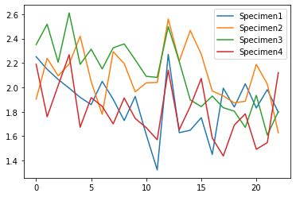

Python Code:
# -*- coding: utf-8 -*-
"""
Created on Fri May 12 19:24:59 2023

@author: AHMET NURİ KİRİŞCİ
"""

import pandas as pd
import os
import statistics
import matplotlib.pyplot as plt
import math

#list format [L,a,w,t]

Specimen_1 = [0.26,0.007,0.02,0.004]
Specimen_2 = [0.26,0.005,0.02,0.004]
Specimen_3 = [0.224,0.005,0.02,0.004]
Specimen_4 = [0.224,0.007,0.02,0.004]

Specimen_pro = [Specimen_1, Specimen_2, Specimen_3, Specimen_4]

#DATA DICTIONARY IS CREATED FOR FURTHER USE
#--------------------------------------------------------------------------------------------

Path = f"Fracture data.xlsx" #BE CAREFULL WITH THE FORMAT

data = pd.read_excel(Path,sheet_name="Sheet1")

DataDic = {}

for col in range (1,5):
datas = []
for value in data.iloc[0:,col]:
if str(value) != "nan":
datas.append(float(value))

DataDic[f"Specimen{col}"] = datas
#-----------------------------------------------------------------------------------------

#CALCULATIONS-------------------------------------------------------------------------------

Frac_dic = {}

for i in range(0,4):

fracture = []

for data_index in range(0,23):

alfa = Specimen_pro[i][1]/Specimen_pro[i][2]

if alfa <= 0.4:
#print(alfa,"Assumption Holds")
Formf = 1.12

Moment = (9.81*DataDic[f"Specimen{i+1}"][data_index]) * 0.5 * (Specimen_pro[i][0]/2)

#print(Moment)

gross = (6*Moment)/((20*10**(-3))**(2)*4*10**(-3))
#print(gross*10**(-6))

Fracture = Formf * (gross)*math.sqrt(math.pi*(Specimen_pro[i][1]))

fracture.append(Fracture*10**(-6))

Frac_dic[f"Specimen{i+1}"] = fracture

# FRACTURE TOUGHNESS VALUES FOR CHOOSEN GROUP DATA-------------------------------------------------------

print("DAY4 GROUP1 SPECIMEN FRACTURE TOUGHNESSE")
print(Frac_dic["Specimen1"][12])
print(Frac_dic["Specimen2"][12])
print(Frac_dic["Specimen3"][12])
print(Frac_dic["Specimen4"][12])

#------------------------------------------------------------------------------------------------------------------

#PRINTS THE VALUES WHICH IS DESIRED--------------------------------------------------------------------------------
print("MEAN VALUES FOR EACH SPECIMEN AS IN THE ORDER 1,2,3,4")
print(str(statistics.mean(Frac_dic["Specimen1"]))+"\n"+str(statistics.mean(Frac_dic["Specimen2"]))+"\n"+str(statistics.mean(Frac_dic["Specimen3"]))+"\n"+str(statistics.mean(Frac_dic["Specimen4"])))
print()
print("STANDARD DEVIATION VALUES FOR EACH SPECIMEN AS IN THE ORDER 1,2,3,4")
print(str(statistics.stdev(Frac_dic["Specimen1"]))+"\n"+str(statistics.stdev(Frac_dic["Specimen2"]))+"\n"+str(statistics.stdev(Frac_dic["Specimen3"]))+"\n"+str(statistics.stdev(Frac_dic["Specimen4"])))

#----------------------------------------------------------------------------------------------------------------------------------------

"""

"Specimen_pro" list contains the properties of the each specimen list within list format

"Frac_dic" dictionary contains calculated fracture toughness value for each specimen, keys are the specimen names

"Data_dic" dictionary contains excel data for each specimen, keys are the specimen names

Note : for code to work properly code file and the excel file must be in the same folder

"""

#PLOTTING------------------------------------------------------------------

fig, ax = plt.subplots()

# Plot the data from the dictionary
for key, values in Frac_dic.items():
ax.plot(values, label=key)

# Add legend
ax.legend()

# Show the plot
plt.show()
#--------------------------------------------------------------------------

